UI Testing Tools & Details

Contents

**1.** **Introduction:** 2

**1.1.** **What is UI Testing?** 2

**1.2.** **UI Testing Types and Tools** 2

**2.** **Tools Details** 2

**2.1.** **Padding & Spacing Check** 2

**2.2.** **Fonts Check** 3

**2.3.** **Content Check** 4

**2.4.** **Hyper Links or URL Check** 6

**2.5.** **Accessibility check** 7

**2.6.** **Responsive testing or Compatibility Testing** 8

# **Introduction:**

This document provides fundamental knowledge on UI Testing, and step-by-step description on various tools leveraged for UI Testing, specifically for the beginners.

## **What is UI Testing?**

User Interface is the design, look and feel of the application through which the end users interact with the software to achieve their needs. Hence testers perform various checks to ensure the UI is built as per the requirement, for its user friendliness and web analytics friendliness.

## **UI Testing Types and Tools**

|  |  |  |
| --- | --- | --- |
| **Sr. No** | **Testing Types** | **Tools** |
| 1 | Padding & Spacing Check | DevTools |
| 2 | Fonts Check | WhatFont |
| 3 | Content Check | Text Compare |
| 4 | Links/URL Check | Link miner |
| 5 | Accessibility check | Axe / Lighthouse |
| 6 | Responsive testing  (Device/Browser Compatibility Testing) | Browserstack / Lambdatest |

# **Tools Details**

## **Padding & Spacing Check**

**Tool:** DevTools

**Description -** Developer tools is incorporated into the Google Chrome, Firefox, Safari, and Internet Explorer web browsers. By accessing this tool, user can view styles & padding information of the page behind the web content.

**Steps:**

1. Open the webpage
2. Press F12
3. Click on Styles and scroll down completely to check the padding.

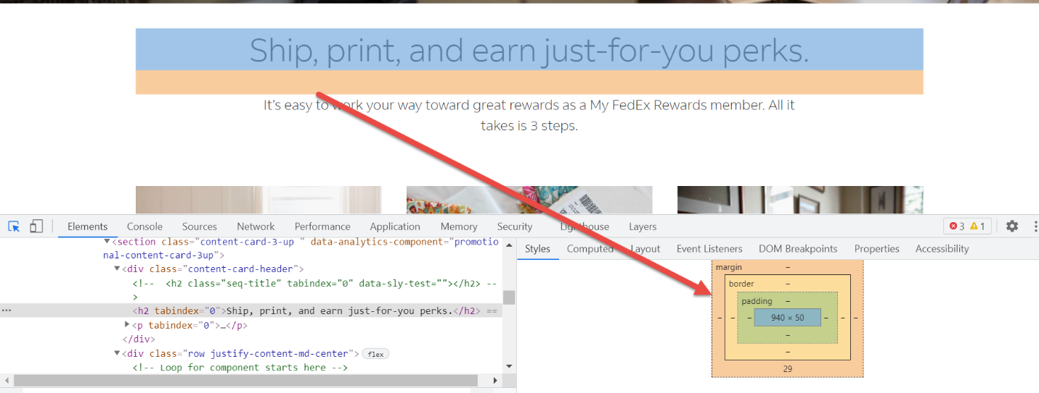

## **Fonts Check**

**Tool:** WhatFont

**Description** – This tool is used to find out the fonts used in a webpage. It helps user to inspect web fonts by just hovering on them. Using this tool on click of the text, following information is available:

* Font Family
* Font weight
* Font size
* Font line height
* Font color

**Steps:**

1. Install WhatFont Chrome Plug-in

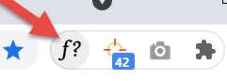

1. Click on the WhatFont plug in and click on the desired text.

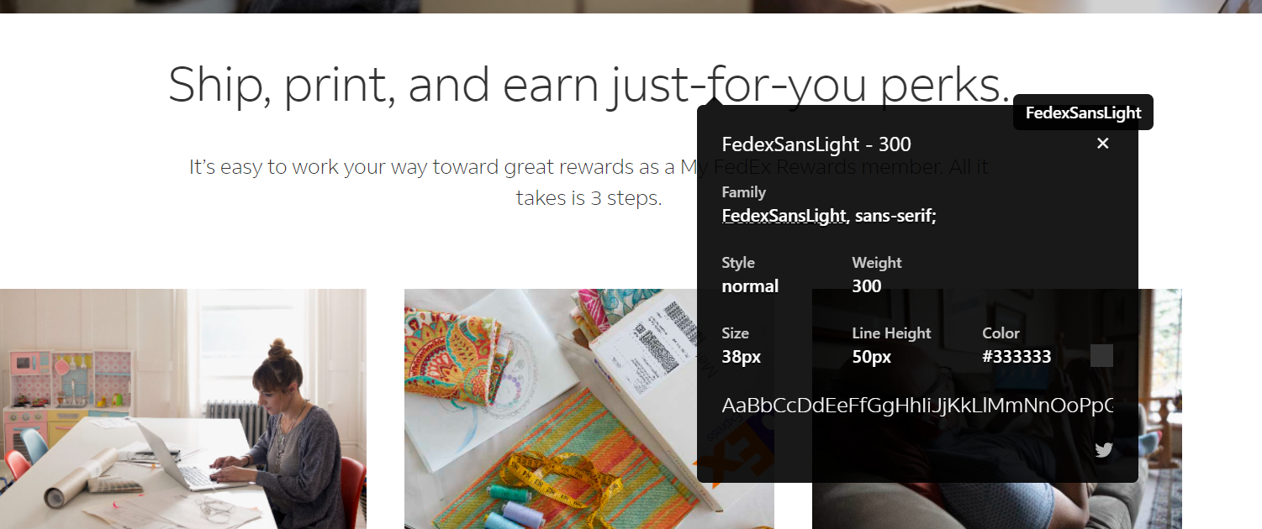

**Result:** Compares the Font family, font size & font color of the text is as per the expected requirements or not.

## **Content Check**

**Tool 1:** Text Compare

**Description -** It is an online **tool** that allows user to easily make a **text comparison** and find the differences between two **texts**. User must paste the two **texts** and hit the **compare**

button. It displays following differences:

* Case Sensitive (differentiating between uppercase & lowercase letters).
* Gap/ spacing differences.
* Missing content.

**Steps:**

1. Go to <https://text-compare.com/>
2. Copy and paste the expected and actual content and you can see the content difference.

**Result:** Content mismatch, case sensitive & spacing differences can be found out when compared with the expected requirements.

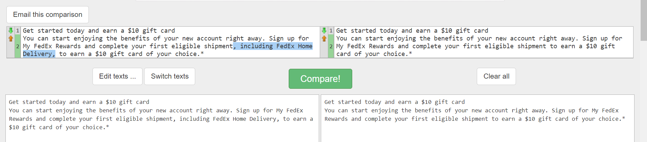

**Tool 2 :** CopyScape

**Description –** It is a tool used for comparing the content of two web pages. User must enter the expected & actual URL of the pages to be compared. It displays the content difference/ mismatch in the pages.

**Steps:**

1. Goto URL - <https://www.copyscape.com/compare.php>
2. Enter the expected URL in Item 1 field & Actual URL in Item 2 field **or**

Copy and paste the expected and actual content and you can see the content difference.

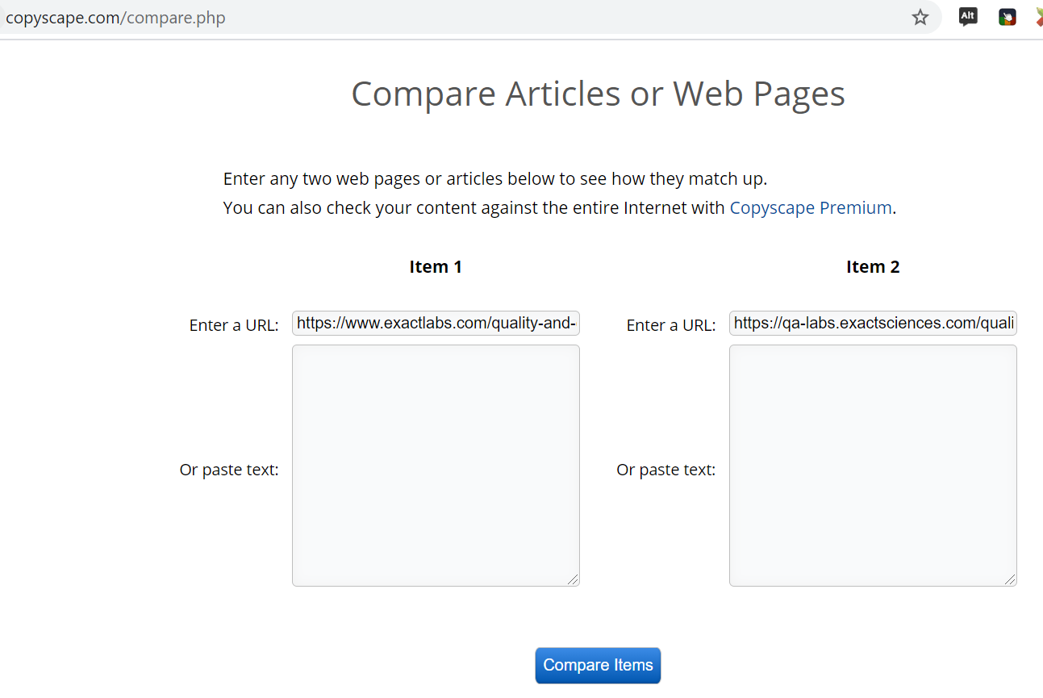

1. Click on ‘Compare Items’.

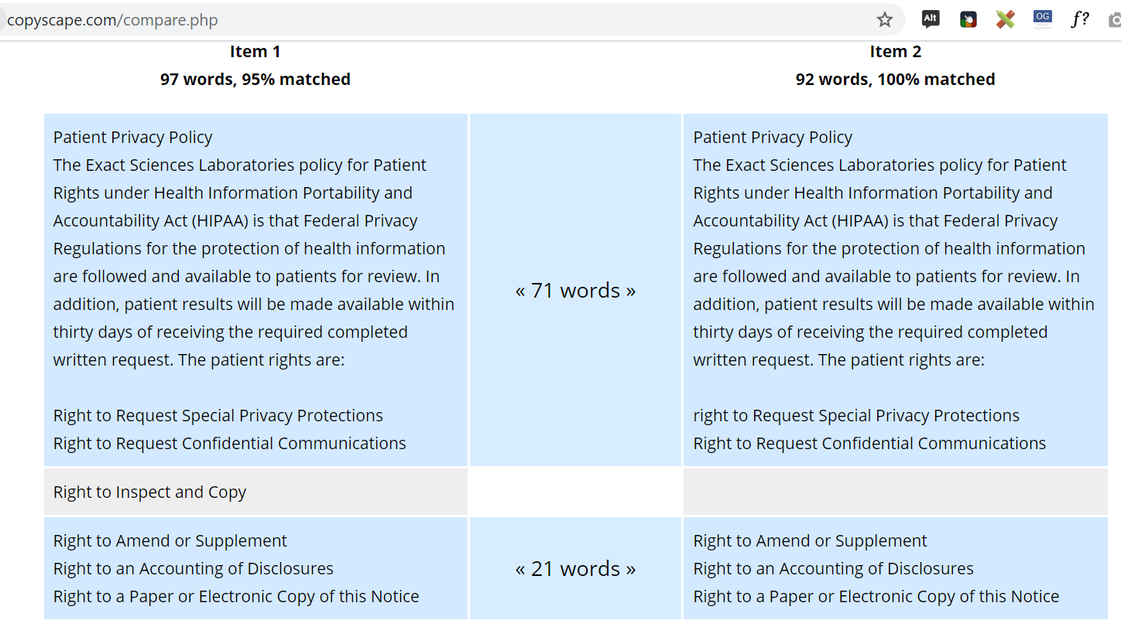

**Result:** Missing content/content mismatch will be displayed in grey color shade.

## **Hyper Links or URL Check**

**Tool:** Link miner

**Description:** It is a tool used for checking broken links in webpages. to find out how many total or external links are on the page user is viewing.

**Steps:**

1. Install the LinkMiner Plug-in
2. Access the webpage where you want to check broken links
3. Click on LinkMiner.
4. It will highlight the links in Red if it’s a broken link.

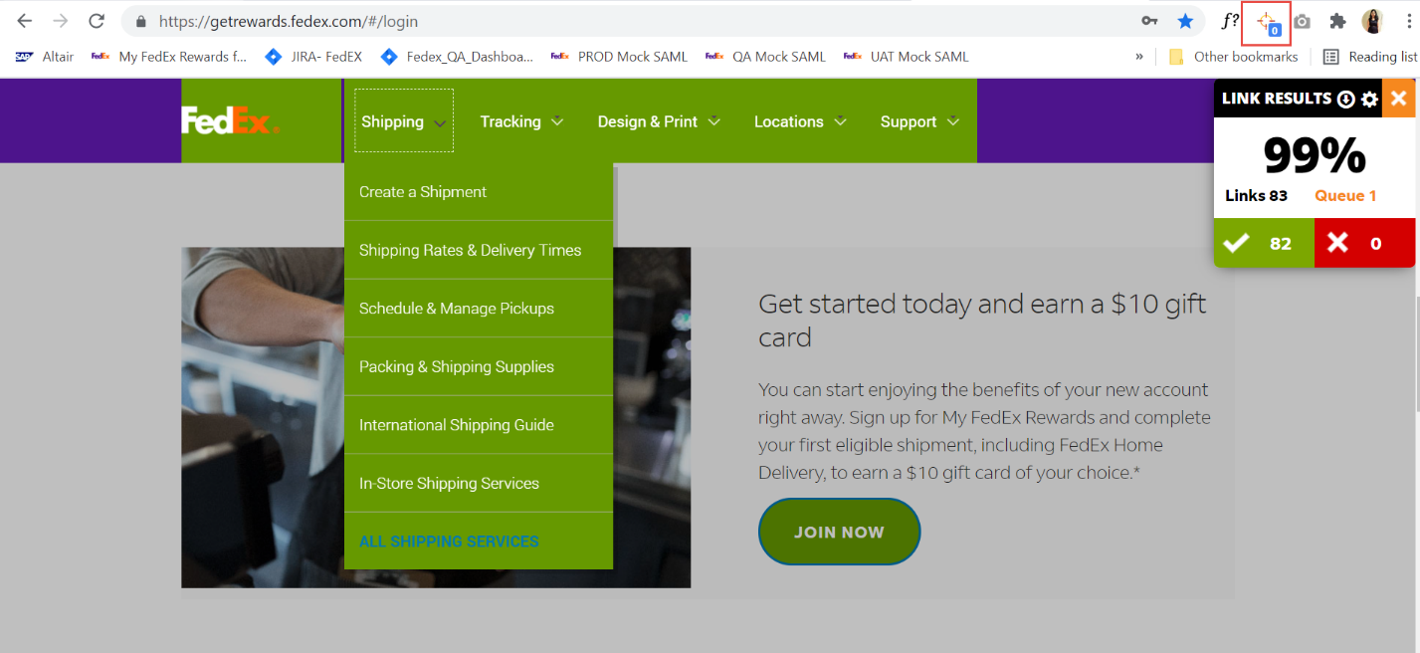

## **Accessibility check**

**Tool:** Axe (or Lighthouse)

**Description** – This tool is used to test accessibility of web pages. It will allow users to analyze a web page and see the accessibility issues in a panel below the web page.

**Steps:** To check AA Compliance

1. Install the AXE Plug-in.
2. Access the Webpage where compliance testing needs to be run.
3. Click on DevTools and click on Scan All of My Page.

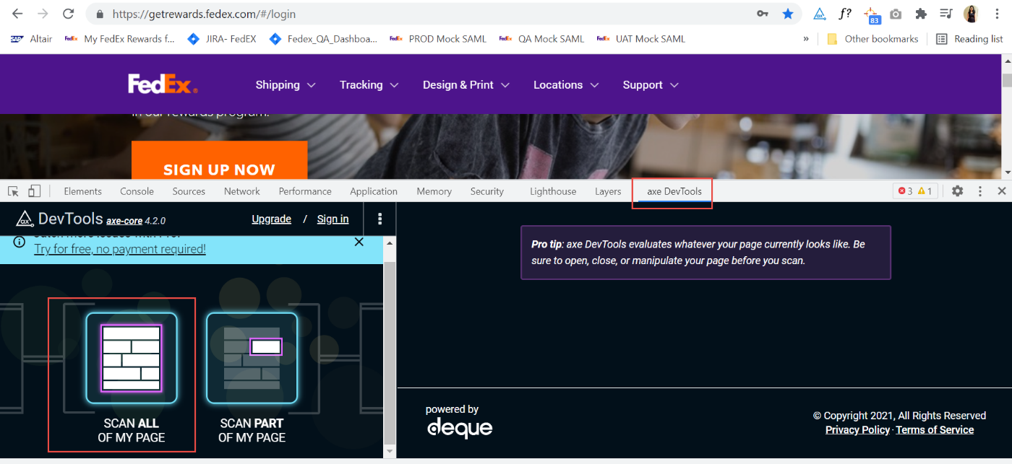

1. You can either run the Compliance for the entire page or part of the page, as per the need.
2. This will capture all accessibility issues

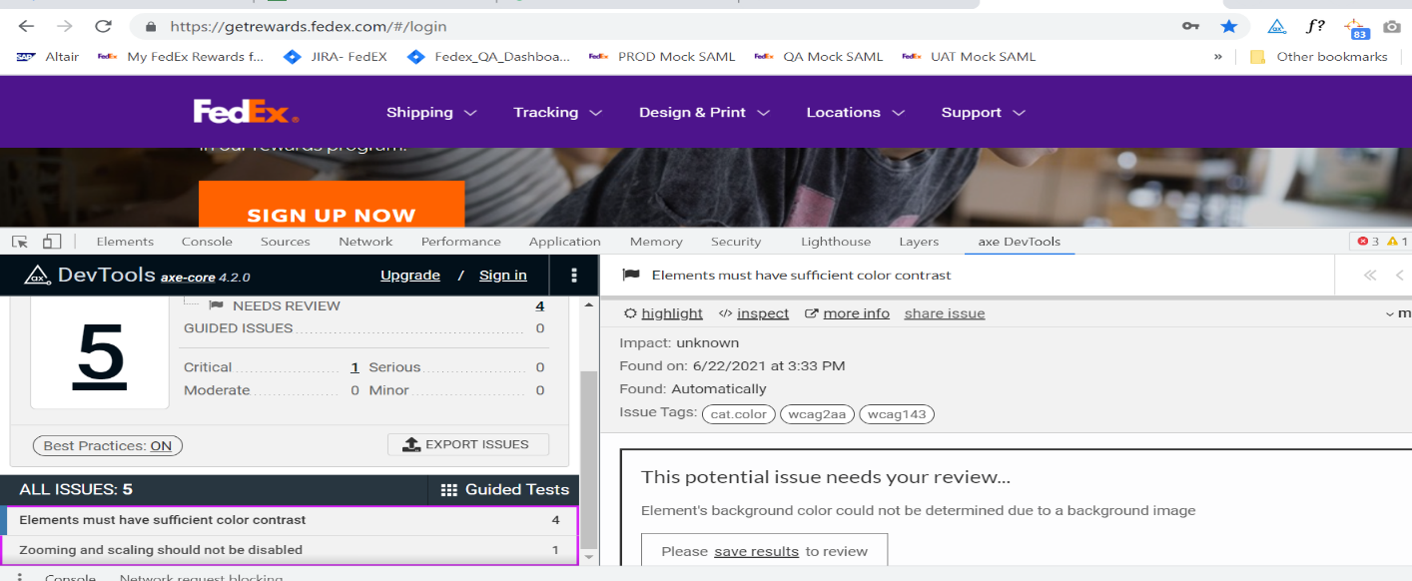

## **Responsive testing or Compatibility Testing**

**Tool:** Browserstack Or Lambdatest

**Description:** BrowserStack is an Indian cloud web and mobile testing platform that provides users with the ability to test their websites and mobile applications across on-demand browsers, operating systems and real mobile devices. This platform provides instant access to 2,000+ real mobile devices and browsers on a highly reliable cloud infrastructure that effortlessly scales as testing needs grow.

**Steps:**

To test in different view ports/ Devices

1. Go to https://www.browserstack.com/
2. Sign in with the credentials.

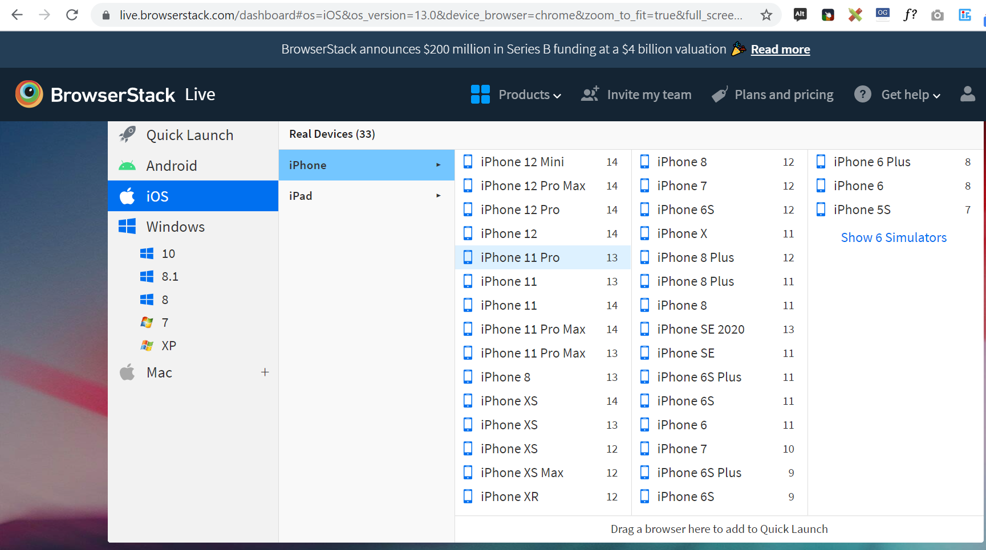

1. Enter the URL to check on devices

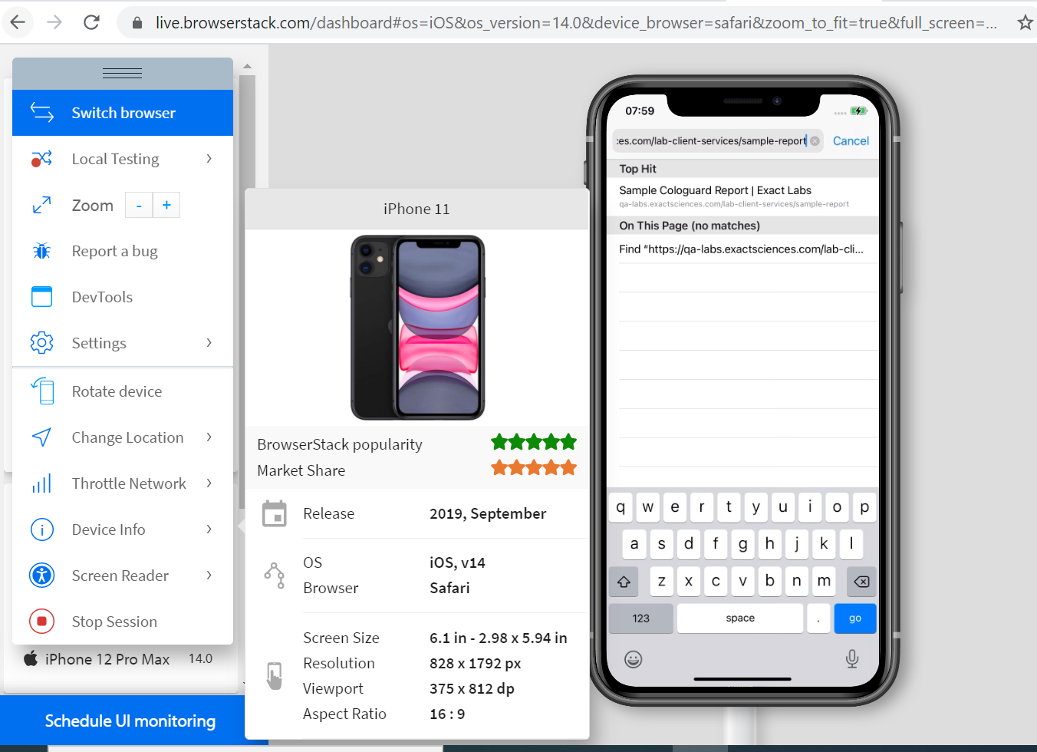

1. The webpage will be displayed in selected device

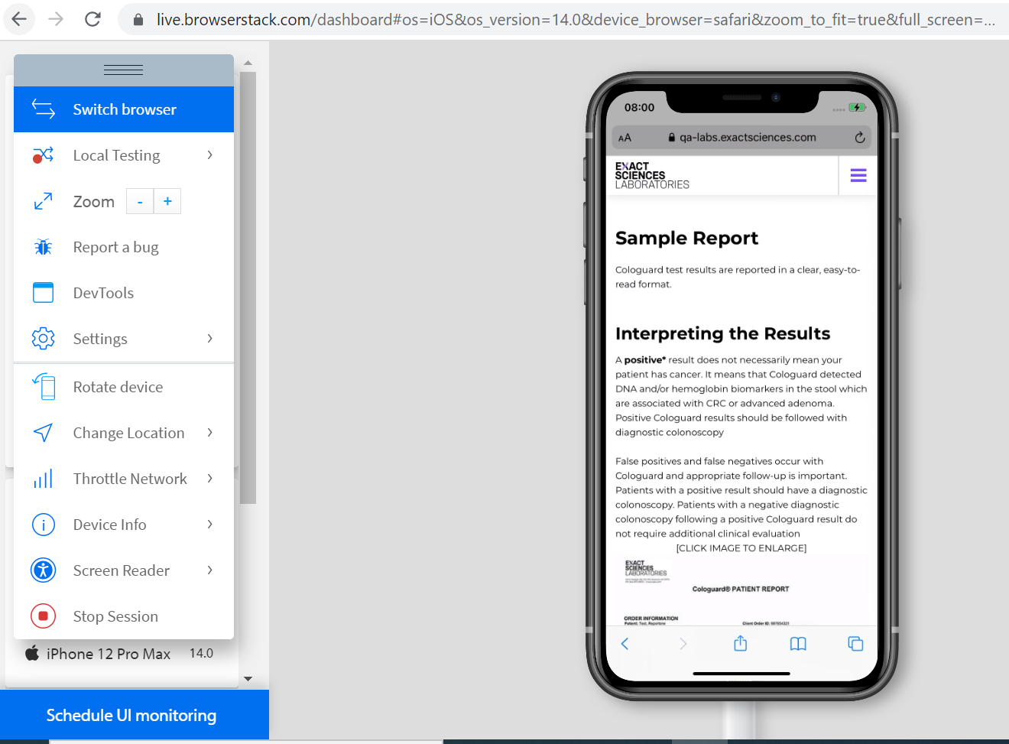

1. Rotate the device to view in landscape mode.

